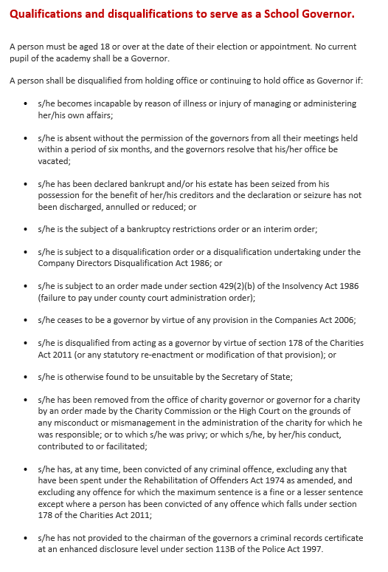
CFS Parent Governor Nomination Form
Please enter in BLOCK LETTERS, the name and address of the person being nominated for election:

Name
Parent/Carer of…
Address
Signature of Nominee
Signature of Proposer
Address of Proposer
I wish to submit my nomination for the election of Parent Governor.
I confirm that I am willing to stand as a candidate for election as a Parent Governor and that I am not disqualified from holding office for any of the reasons set out in the attached.

Signature
Date
Completed nomination forms must be returned to the School by 1500 on Friday 14 November 2025 via governance@chichesterfreeschool.org.uk
Personal Statement (maximum 250 word)

